1. 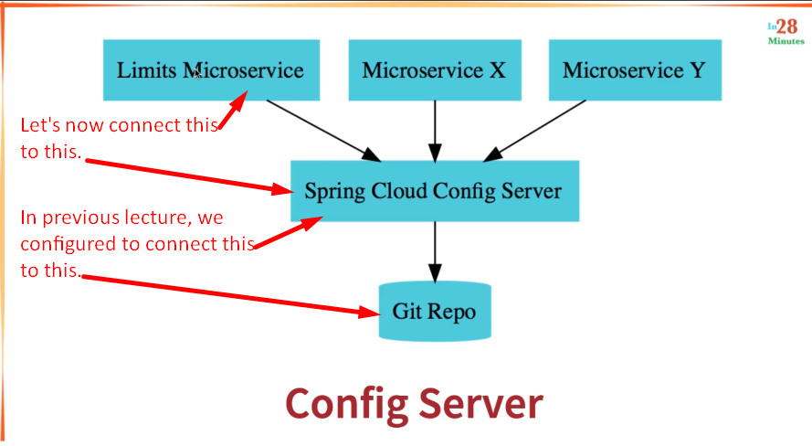
2. There are two important configurations to connect Limits service to Spring Cloud Config Server.
3. 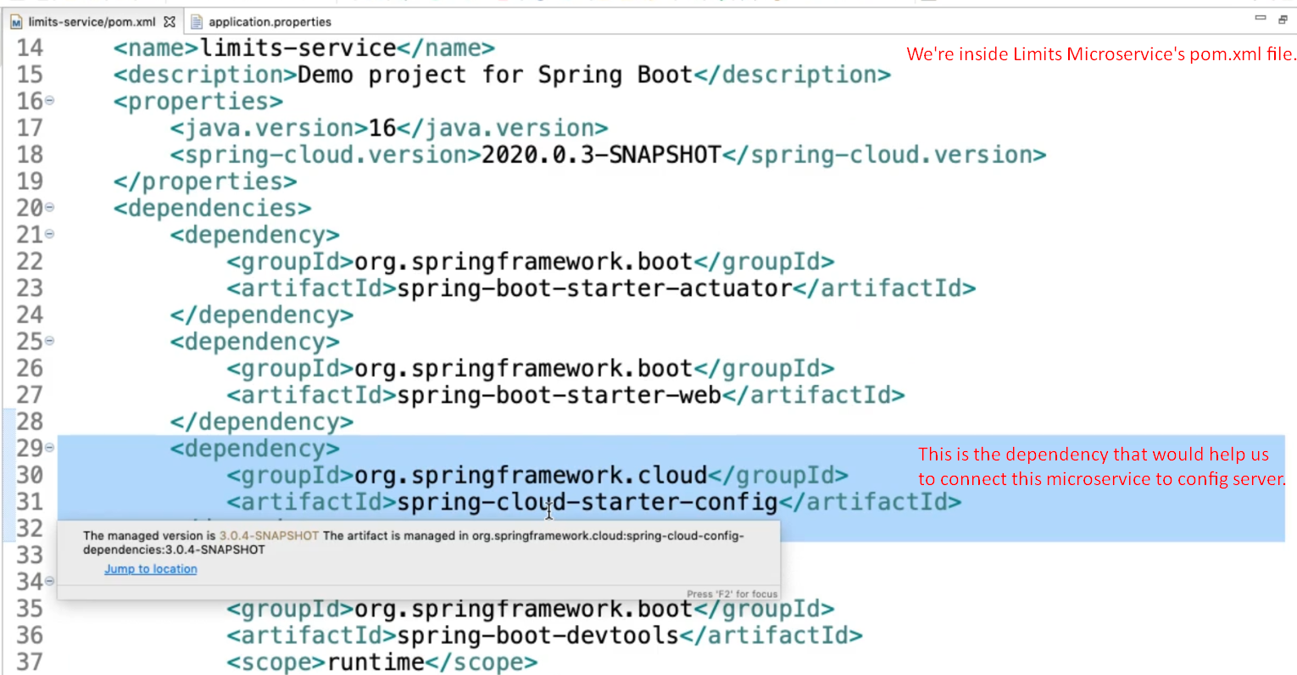
4. 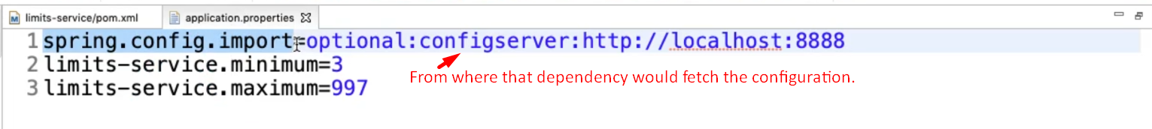
5. What is the name of this application?

Means what configuration in the cloud Config Server should this application make use of?  
Let’s see what application name is to be given to this Limits Microservice. Let’s go to the property file in git used by Config Server.  
